**Lesson 6 Demo 1**

**Running First Playbook**

|  |
| --- |
| **Objective:** To create and install NodeJS using playbook  **Prerequisites:** You need to have Python 2.7 or higher, minimum 8 GB RAM, and SSH or SCP communicator.  **Tools required:** Ansible |

**Steps to be followed:**

1. Creating a Playbook
2. Running Ansible YAML script

**Note:**

* *Connect to the local server like in the previous demo (Setting up Ansible) using* **ssh localhost -p 42006** and *then proceed with this demo.*

1. **Creating a playbook** 
   1. Add the following code in the node.yml file and proceed with execution:

**sudo nano node.yaml**



* 1. Add the following code in the **node.yaml** file. Make sure that the formatting is right and there are no extra white spaces, and the code is written as shown below:

**---**

**- name: install nodejs**

**hosts: webservers**

**gather_facts: True**

**become: true**

**tasks:**

**- name: add apt key for nodesource**

**apt_key: url=https://deb.nodesource.com/gpgkey/nodesource.gpg.key**

**- name: add repo for nodesource**

**apt_repository:**

**repo: 'deb https://deb.nodesource.com/node_0.10 {{ ansible_distribution_release }} main'**

**update_cache: no**

**- name: install nodejs**

**apt: name=nodejs**

Then press Ctrl+X, choose yes, and then press enter

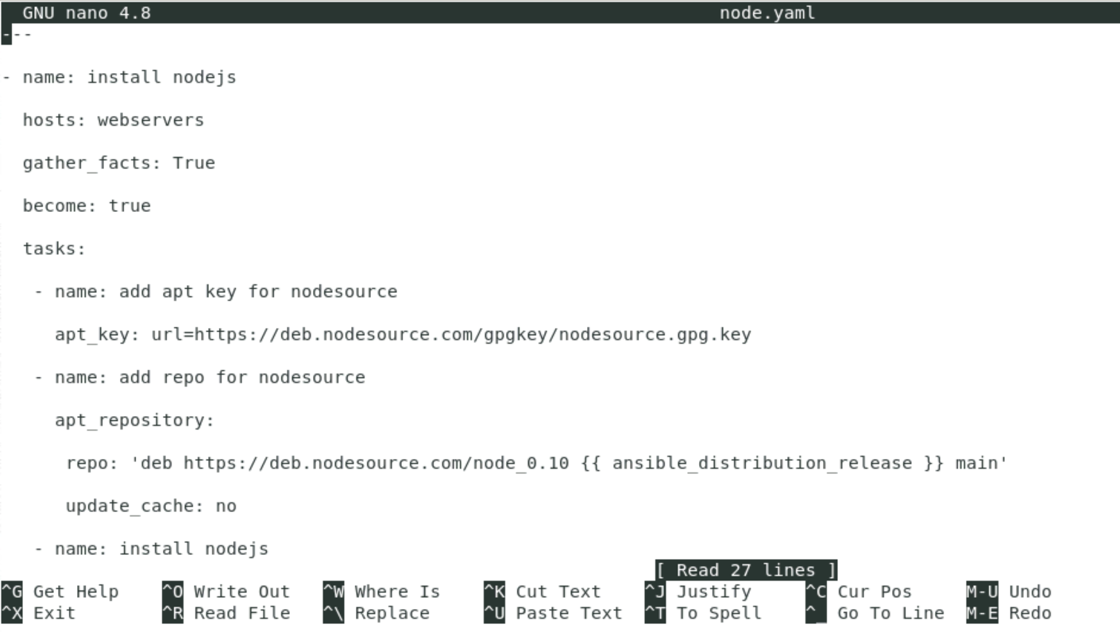

1. **Running Ansible YAML script**
   1. Run apache.yaml file using the command below:

**ansible-playbook node.yaml**

You will see the below screen after successful execution of the playbook:

